**Lab no 3**

**OBJECTIVE:** To learn RMI basics: Generate the stubs and skeletons and run client and server.

**Task:1** Create RMI program in which server performs basic arithmetic operations.

**Interface:**

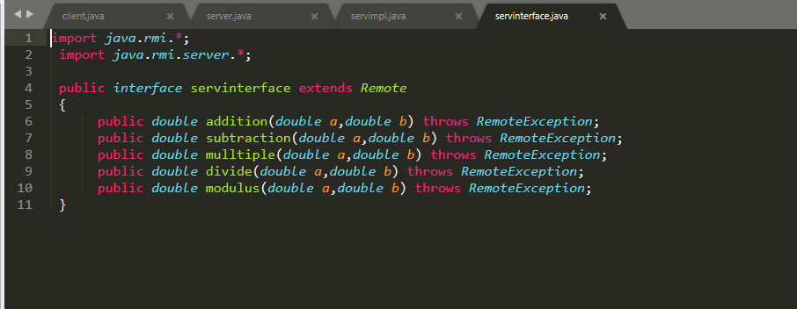

**Server Implementation:**

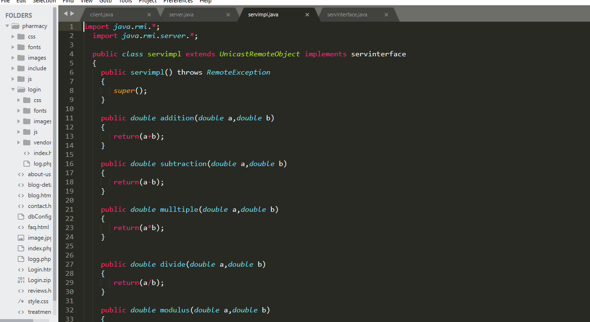

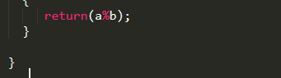

**Server:**

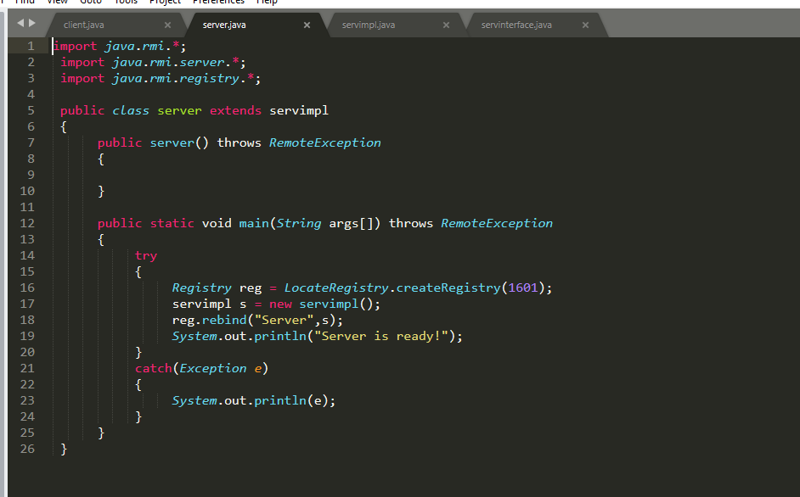

**Client:**

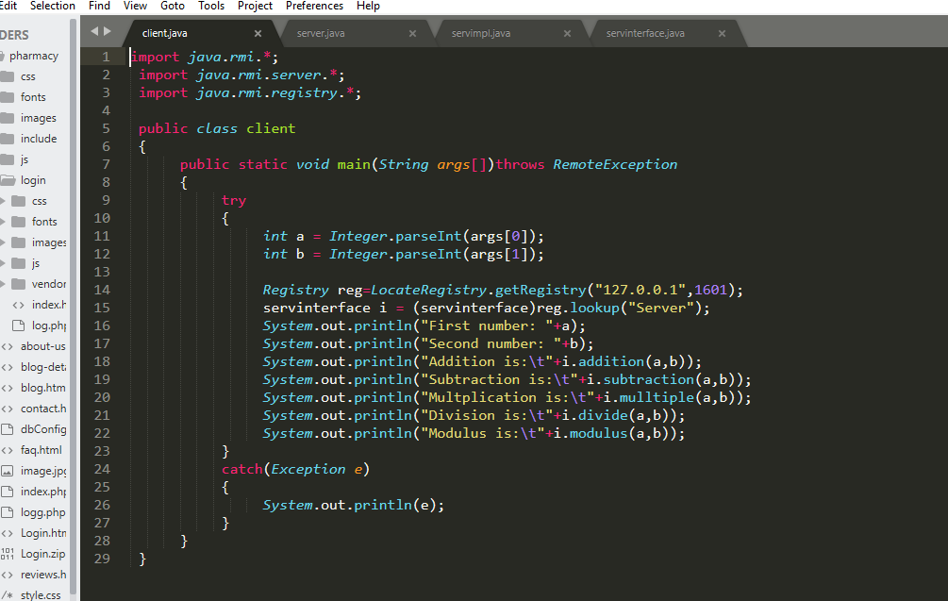

**Output:**

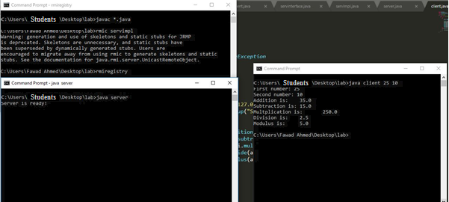

**Task2:**

Create RMI program in which server sorts the numbers in ascending order.

**Interface:**

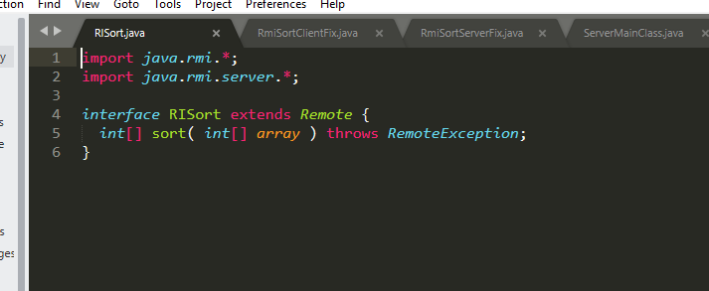

**Client:**

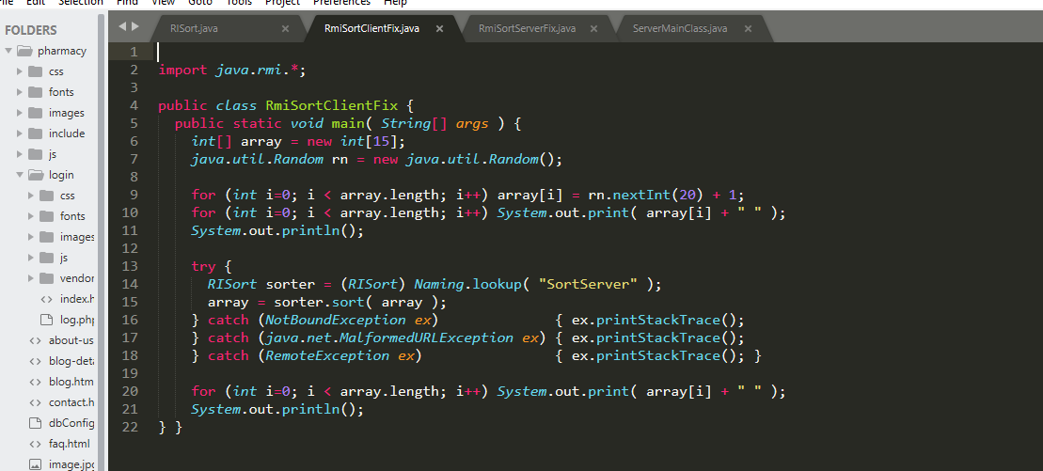

**Server:**

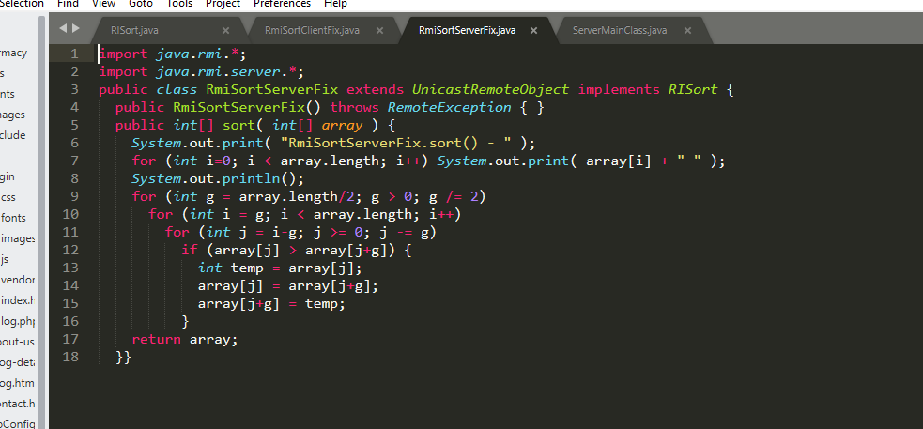

**Server Main:**

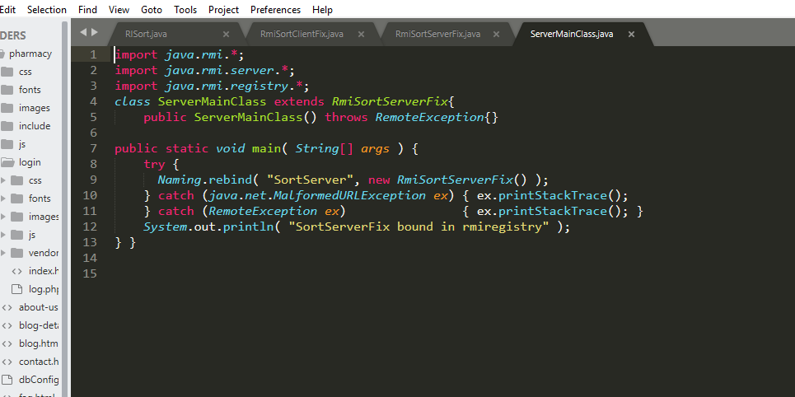

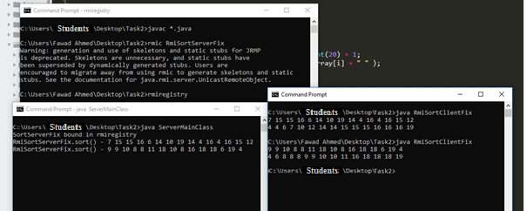

**Task:3**

Write an RMI program to implement the Map/Reduce concept of Hadoop on the server program. In other words the client program asks user to provide multiple sentences and send to server, server sends back the word counts.

**Interface:**

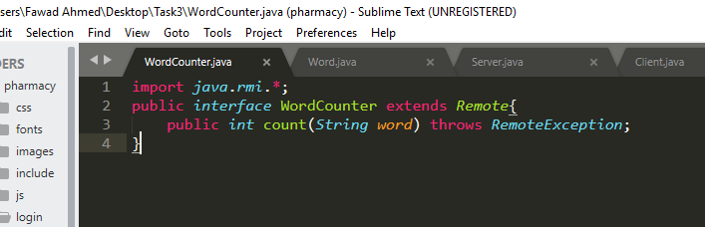

**WordCounter:**

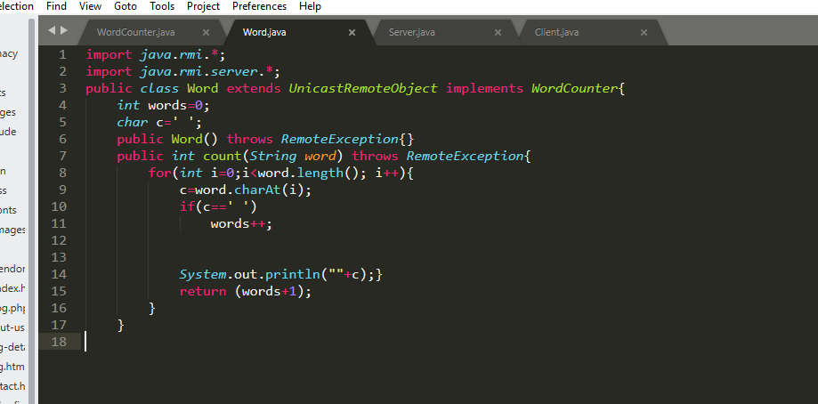

**Server:**

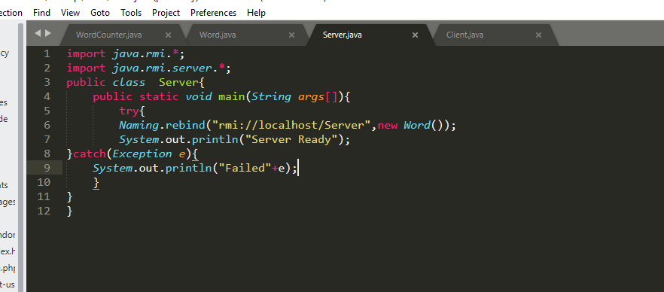

**Client:**

